GIS Practical 2 Worksheet

Name: Max Warriner
Student number: 126104460

GenAI Statement:
The purpose of this assessment is to develop your cartographic and GIS skills – these involve practical skills, understanding of core concepts, and your existing knowledge.
You should not use GenAI for questions 1 and 2. You must demonstrate your core skills and knowledge, making specific reference to the spatial datasets that you are working with.
You should use GenAI for question 3, where you will critically evaluate the outputs of GenAI when prompted to analyse the results of your mapwork.
You should not use GenAI during the assessment; you should demonstrate your core skills and knowledge.
Academic integrity:
By submitting this assignment, you are certifying that the work you are submitting is your own and has been done by you and not in consultation with anyone else. You, or anyone else, have not submitted this work for assessment already, either at University College Cork or elsewhere. You have read and understood University College Cork’s Academic Integrity for Examinations and Assessments Policy (available here). You understand that the work you are submitting may be checked for academic misconduct and plagiarism, in line with the policy, and that this can result in a reduction in marks or other penalties.

Guidelines:
You should complete the questions in the worksheet (30% of your grade) and either insert your mapwork (worth 70% of your grade) on the last page or upload your map as a separate file through Canvas.
None of the text section answers should be more than 100 words.

GIS Practical 1 – Spatial data models
- What spatial data models have you worked with when completing this practical? (approximately 50 words)

I’ve worked with both raster and vector data in this practical. The vector data is in the form of secondary school locations and county lines. The raster data is in the form of rainfall differences and temperature differences.

- How have you defined and identified the schools projected to have the largest change? (approximately 50 words)

The school with the largest projected change in rainfall is the Ballinamore Vocational School in Donegal, with a projected increase in 104 cm of rainfall (>1.5 standard deviations). The highest concentration of schools affected by an increase in rainfall is in County Donegal.

- You should be confident that you can outperform Generative AI in doing spatial analysis. This is because you have intelligence; you have practical skills, you have core knowledge, and you know how to apply them. Here, let’s work on your critical thinking skills and evaluate GenAI’s ability to analyse the results of your mapwork.

On the page 4 there is an example of the type of answer that Chat GPT returns when given a graduated colour symbol map of schools experiencing change in precipitation (figure 1 is the prompt with initial response, figure 2 is the ‘100 word undergraduate geography answer’).

Using either the example in these figures or your own prompt (delete figure 1 and 2, paste in your own prompts), critically assess what does GenAI get right and what does it get wrong when analysing you mapwork? Do you think that the answers that it produces are accurate? (approximately 400 words)

Please note – you should be the one critically evaluating the technology, not asking the technology to evaluate itself. Think about what you can see/do in GIS software that it can’t.

Starting with what seems correct about what GenAI says about my map, I think that it’s accurate to point out that changes in rainfall are not necessarily consistent with changes in temperature, and that changes in rainfall are more scattered and seemingly random throughout Ireland, compared to changes in temperature. I also think it analyses the shift in temperature change from north to south accurately, pointing out some correct counties, though I would say Clare and Limerick have even more warming than Waterford and Wexford. I would also say that it correctly points out that most regions in Ireland have mixed results in terms of increasing/decreasing rainfall, with no clear pattern regarding north/south, east/west, and inland/coastline. It correctly identifies risks for southern schools with responses to heat, though saying some east/west schools will have increased rainfall is a bit unhelpful since it already mentioned earlier that increased rainfall is not easily pinned down to one region.

I think the biggest thing that GenAI misses in my map is the large concentration of schools in the north of Ireland in County Donegal with heavily increased rainfall projected. Looking at my own map, this is one of the few counties that shows consistently high levels of increased rainfall projections.

I also think that when GenAI says,
“East coast (especially Dublin & surrounding counties)
- Dense cluster of schools.
- Many show neutral to increasing rainfall. “

I think this is inaccurate because it looks to me like most schools around Dublin have decreased rainfall, so increasing rainfall is slightly inaccurate.

Overall, I thought GenAI did a fairly good job except for a few points. I think the map is relatively simple to read and analyse, so that could have helped. I also think that GenAI’s ability to think and reason has increased substantially since the last year, making the line between what I’d say about the map versus the AI’s finer and finer.

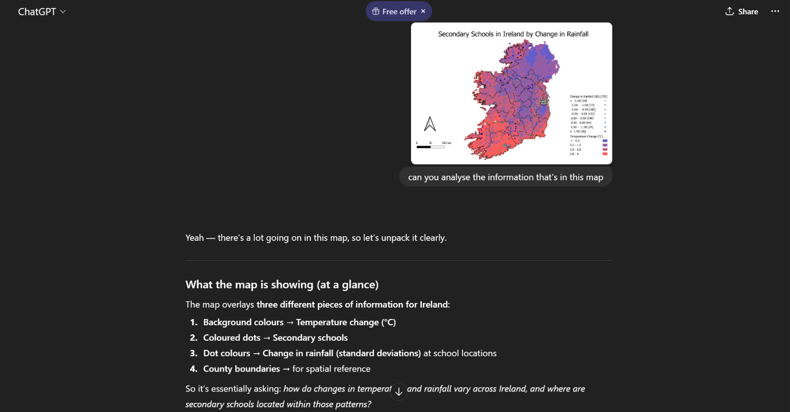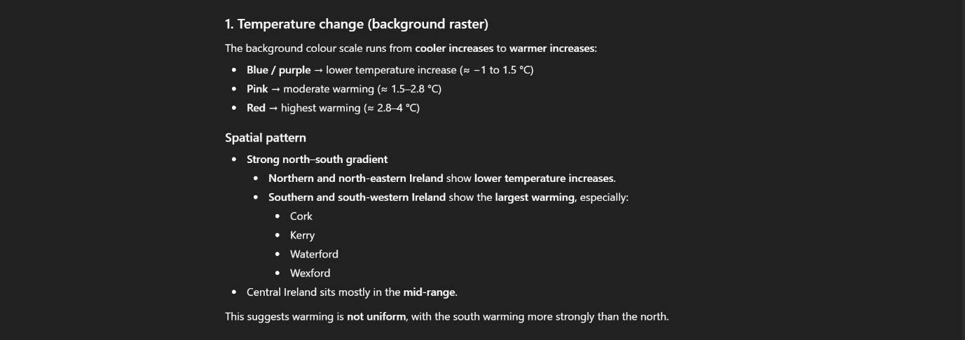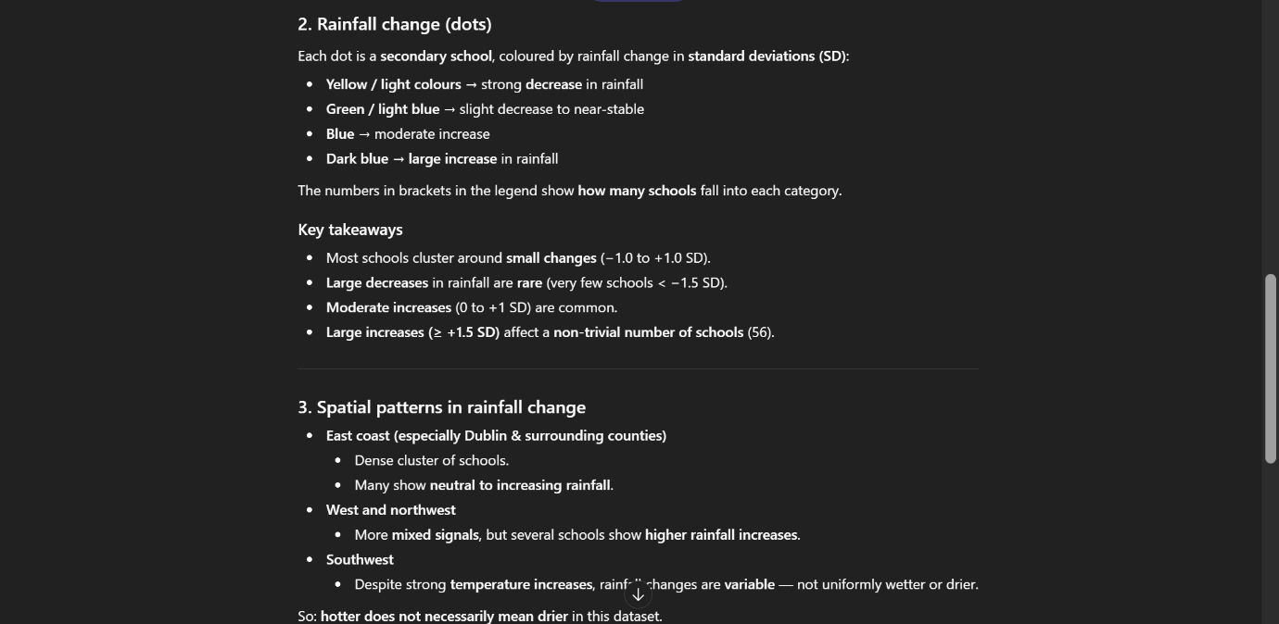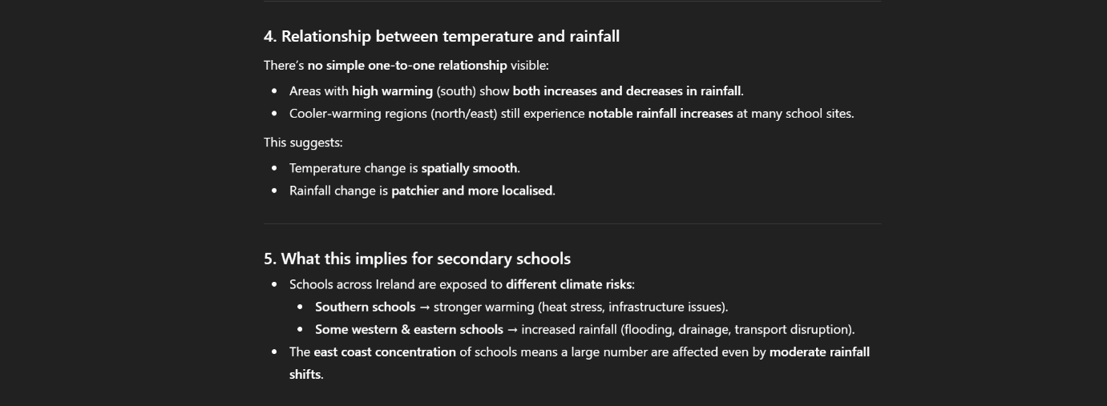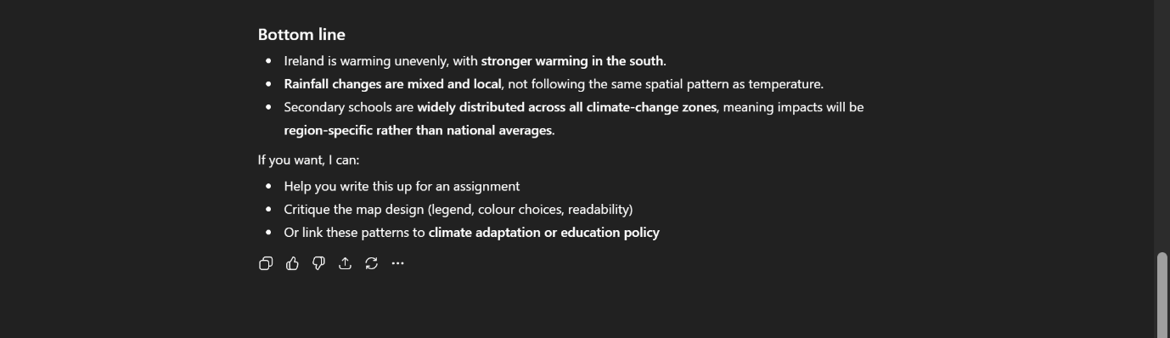
References (if you used any supporting sources):

Mapwork if in landscape layout should be pasted as an image here:
